Directions to Metabolic Nutrition Program

Los Gatos Medical Park, 800 Pollard Road, Building A
The office is directly across the street from El Camino Hospital, Los Gatos
All directions include:
- Turn left from Winchester onto Knowles Dr.
- Knowles Dr ends at Pollard Rd where the road curves (0.4 miles)
- Los Gatos Medical Park is on the left.
- Our office is in the building on the right
- We share space with Dr Steven Swengel

From San Jose:
- Hwy 17 South
- Exit Lark Ave and turn right
- Turn right on Winchester Blvd
- Turn left on Knowles Dr
- Knowles becomes Pollard Ave at 800 Pollard

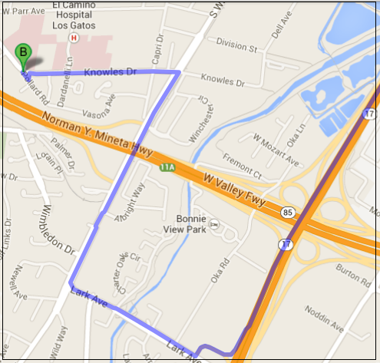

From the Gilroy area
- Hwy 101 North to 85 North
- Hwy 17 South towards Santa Cruz
- Exit Lark Ave and turn right
- Turn right on Winchester Blvd
- Turn left on Knowles Dr
- Knowles becomes Pollard at 800 Pollard

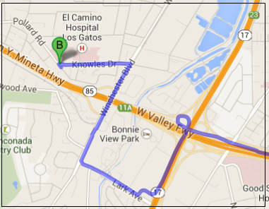

From Santa Cruz area
- Hwy 17 North to San Jose
- Exit Lark Ave and turn left
- Turn right on Winchester Blvd
- Turn left on Knowles Dr
- Knowles becomes Pollard Ave at 800 Pollard
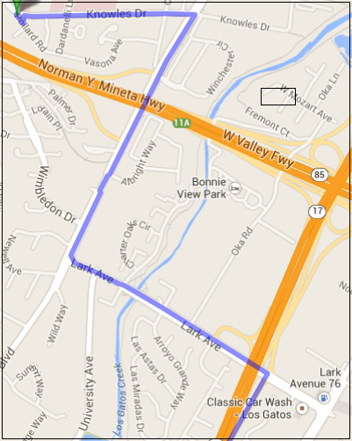

From the Peninsula
- Take 280 South (or 101 South) to Hwy 85 South
- Exit at Winchester Blvd and turn left
- Turn left on Knowles Dr
- Knowles becomes Pollard Ave at 800 Pollard

